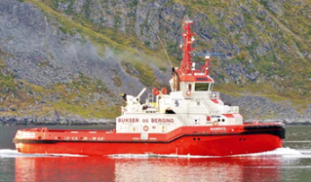 | 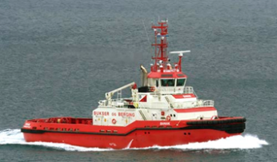 | 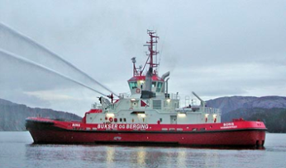
Barents LATC (175m3) Melkøya | Banak LNND (175m3) Melkøya | Boris LNMS (250m3) Melkøya
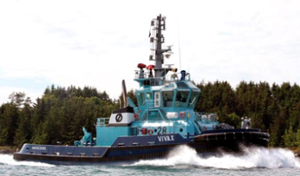 | 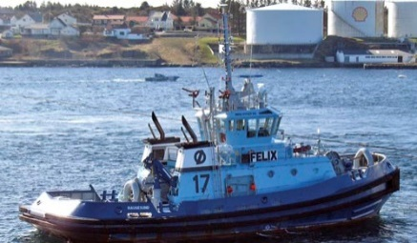
Vivax LAXB (114m3) Nyhamna | Felix LIQK Nyhamna
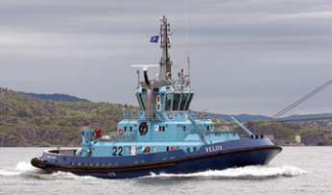 | 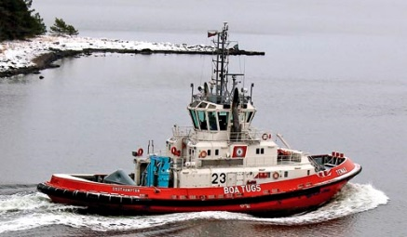 | 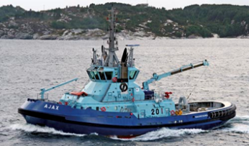
Velox LMQW (146m3) Sture | Tenax LDYI (146m3) Sture | Ajax LLEQ (450m3) Sture
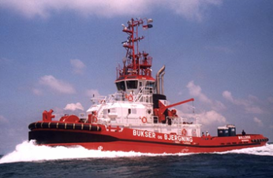 | 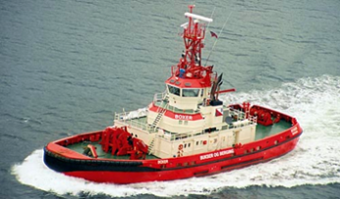 | 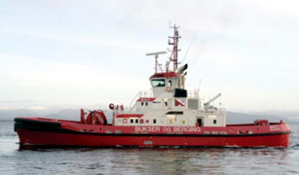
Bulldog LJMG(100m3) Mongstad | Boxer LJRX Mongstad | Baut LMJY Mongstad
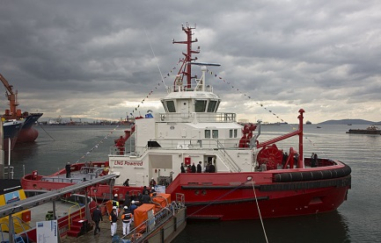 | 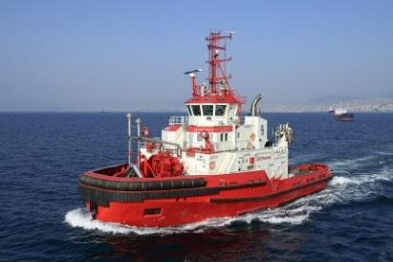
Borgøy LDII (100m3) Kårstø | Bokn LDIJ (100m3) Kårstø

